LINCOLNSHIRE - RIVERWOODS
FIRE PROTECTION DISTRICT

PROFESSIONALISM THROUGH DEDICATION

115 SCHELTER ROAD, LINCOLNSHIRE IL, 60069
(847) 634-2512 - FAX (847) 634-2572

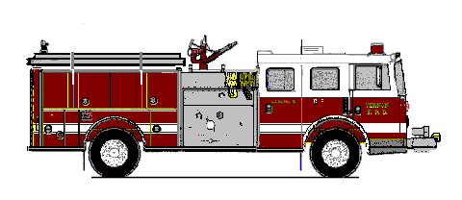
EMERGENCY 911

AGENDA
November 10th, 2023
REGULAR FFIB BOARD MEETING
Station 53 671 woodlands PKWY Vernon Hills IL @730

- CALL TO ORDER
- ROLL CALL
- APPROVAL OF AGENDA
- APPROVAL OF MINUTES
- OPEN FORUM/PUBLIC COMMENT
- CHAIRMANS REPORT
- TREASURER’S REPORT/PAYMENT OF BILLS
- OLD BUSINESs
- NEW BUSINESS
- OTHER MATTERS
  - Espresso makers
  - October shirts
  - LRFD FFIB Resolution 23-24-01 (IML License Fee)
- ADJOURNMENT

